World Domination Strategy Game

Single Player/ Ages 3+

**Global Conquest**

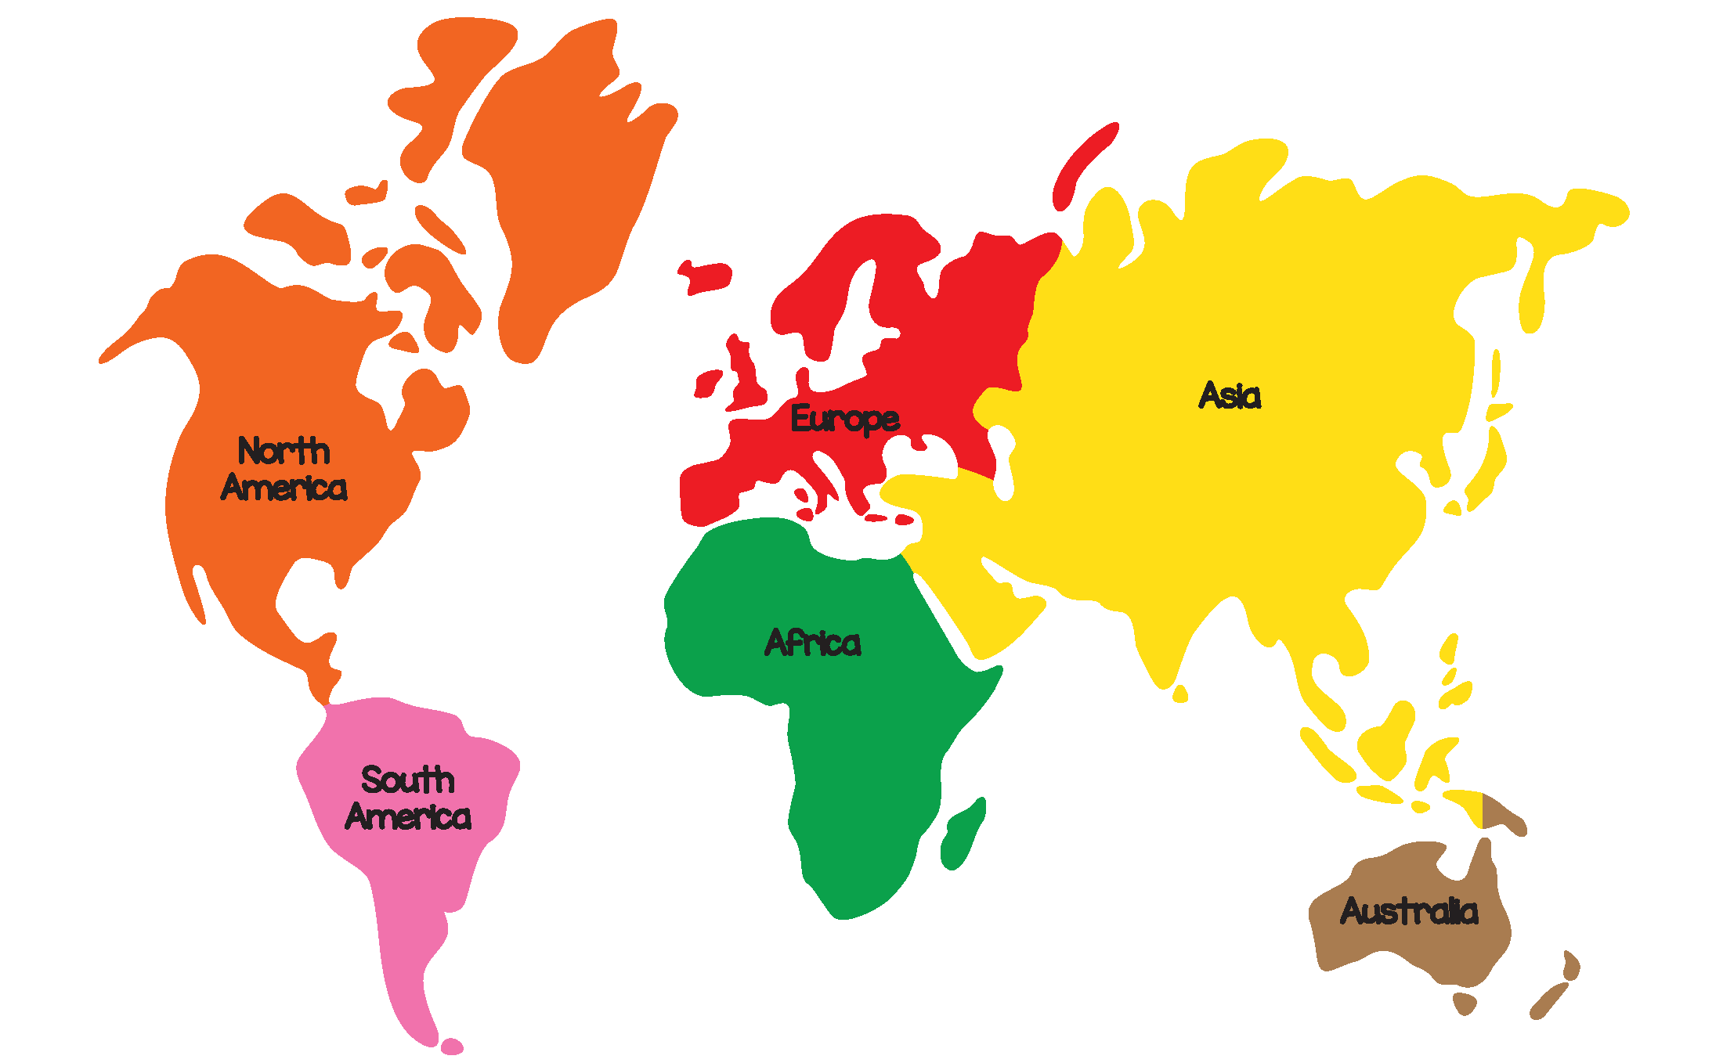

**USER GUIDE**

Table of Contents

Introduction 3

Setup 3

Strategy Hint 3

Territory Information 3

Game Play 4

Initial Troop Allocation 4

Rolling for Attacks/Troops 4

Internal Attacks 5

External Attacks 5

Winning/Losing 6

The Enemy 7

# Introduction

The main objective of Global Conquest is to conquer the world through the occupation of the world map, split into territories. This in turn will happen when you beat the enemy.

# Setup

Once the game has been loaded, the initial troop allocation is a key part of the game. Trying to take control of as many territories as possible within the first move!

## Strategy Hint

Allocate troops to as many of the big territories as possible aka Asia, Africa they have big bonuses!

If the enemy commits large troops to one territory let them have it and make the decision early to go for a territory that only requires a few of your troops to compete for.

# Territory Information

Territories all have their own bonuses and maximum troop capacities, these can be used tactically to help conquer the world. The bonuses of some territories are bigger and more worthwhile than the others the table below gives you the information needed.

|  |  |  |
| --- | --- | --- |
| **Territory** | **Troop Bonus** | **Maximum Capacity** |
| Australia | 2 | 20 |
| South America | 4 | 25 |
| North America | 5 | 35 |
| Europe | 6 | 30 |
| Africa | 6 | 35 |
| Asia | 8 | 50 |

Remember to take into account the connections between territories.

(Australia only connects to Asia)

# Game Play

## Initial Troop Allocation

Once you have loaded the game up, the start screen should look like this.

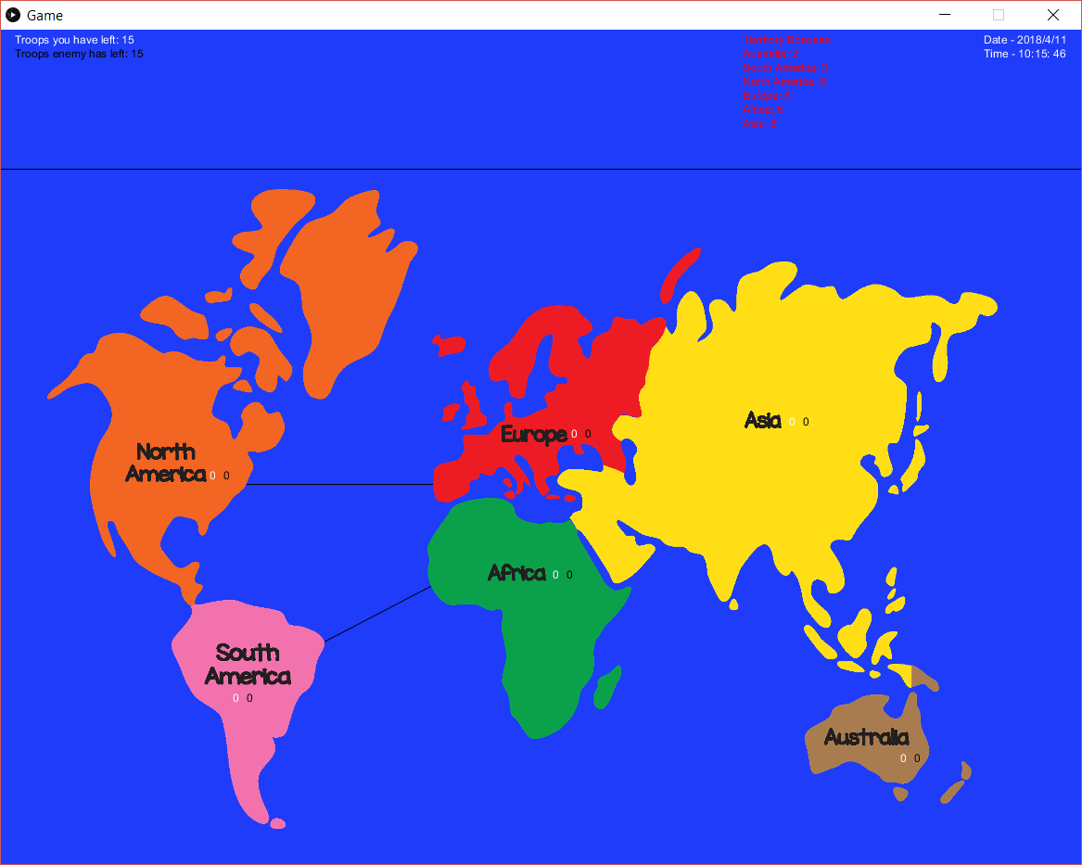

You will have 15 troops to allocate where you wish. Click on a territory to allocate a troop there. Do so wisely.

## Rolling for Attacks/Troops

Once you have run out of troops to allocate in the initial stage, a box will appear in the centre of the screen.

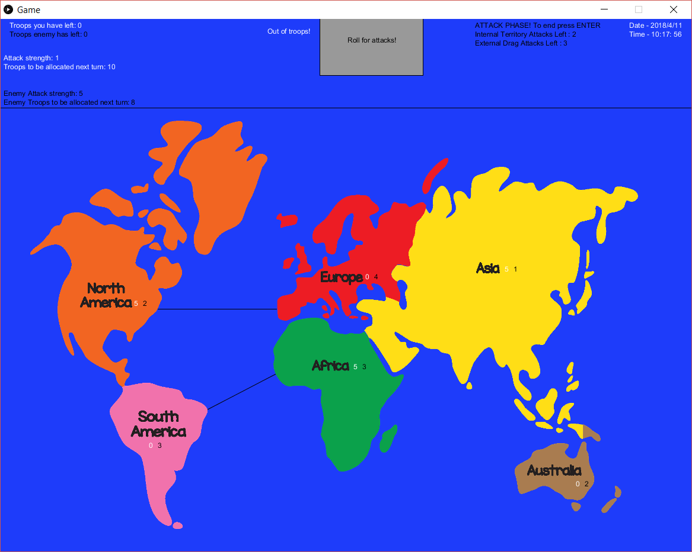

Click this to randomly roll your attack strength (1-6), and your troop reserves for next turn (1-12)



## Internal Attacks

When performing an internal attack, click on a territory with both user troops and enemy troops in it. This will reduce both armies by the attack number you rolled when rolling for attacks.

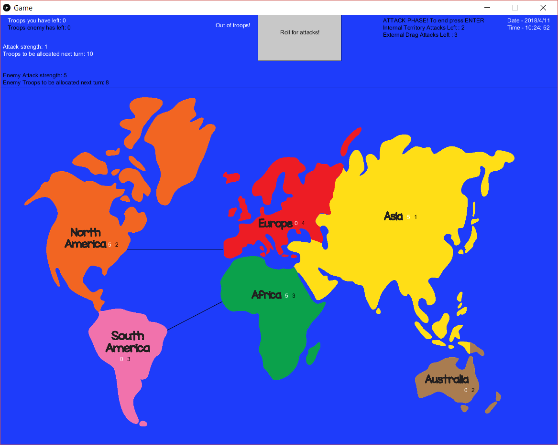 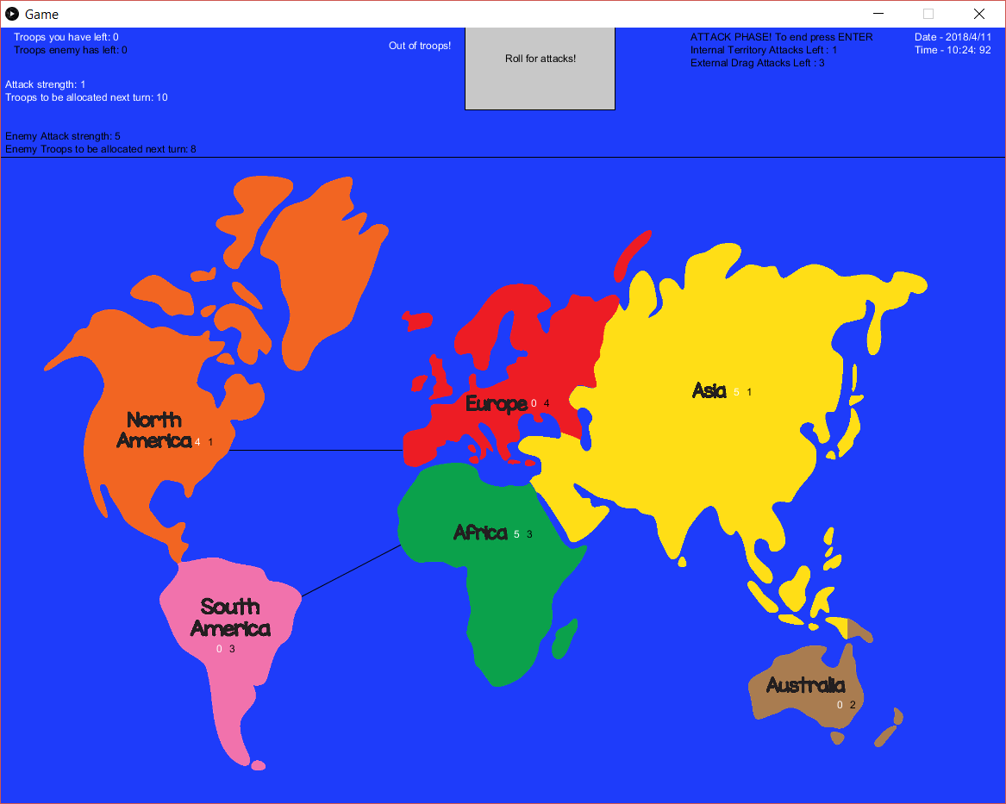 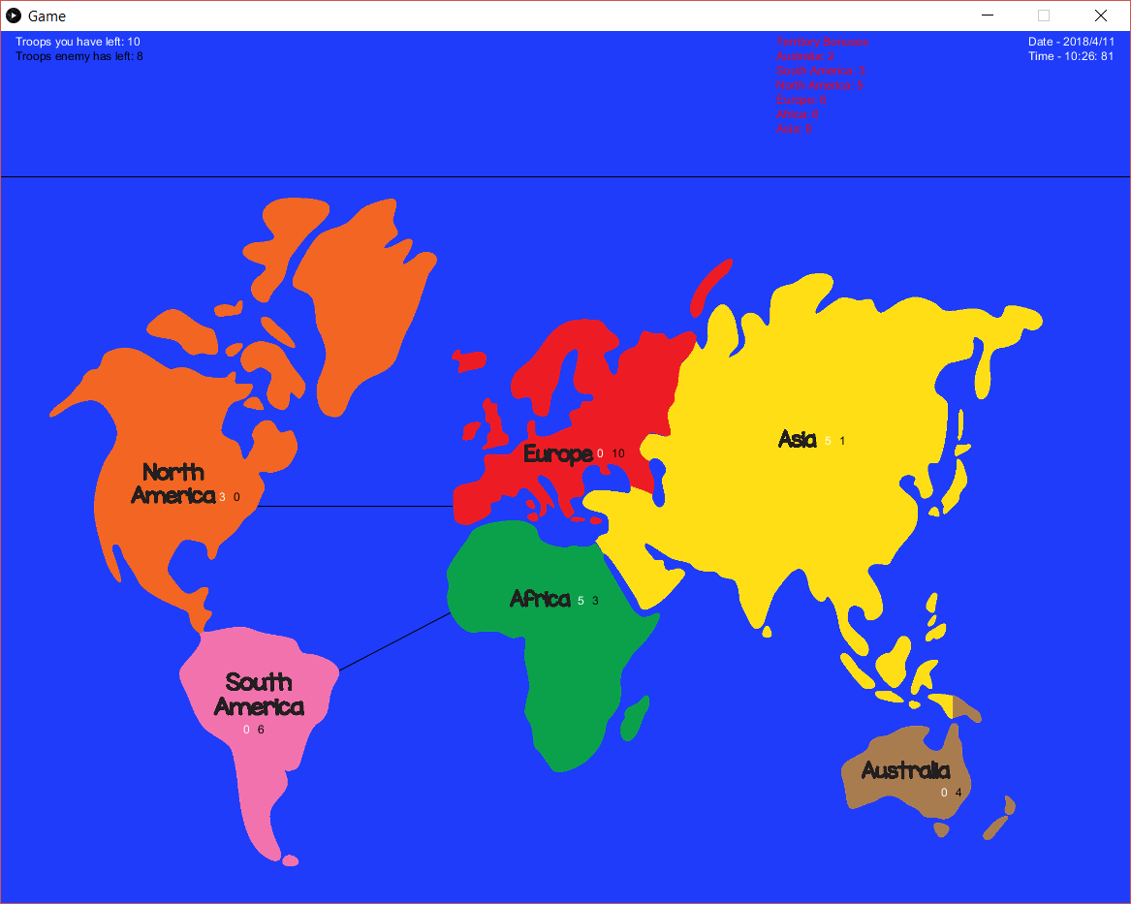

Until either your troops, the enemy troops, or the internal attack count hits 0.

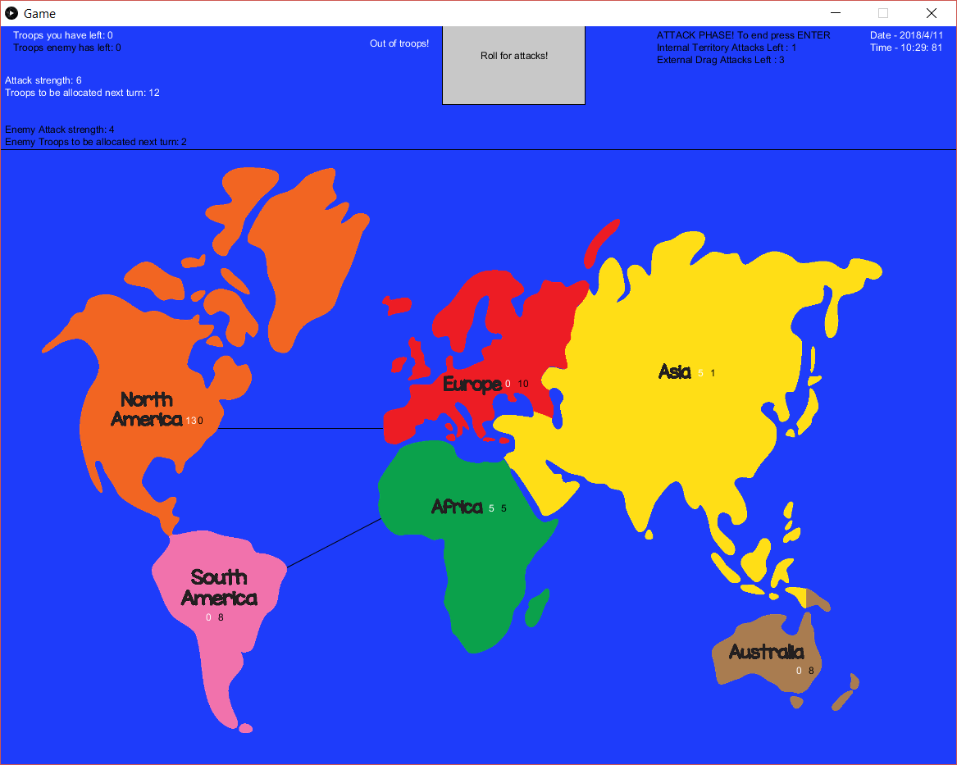

## External Attacks

Also known as drag attacks, allow you to attack territories that are next to ones you own! You must click on a territory you have troops on and the enemy has no troops on and drag it onto another territory.

If you drag onto a territory with enemy troops on it will reduce the amount of your troops and the enemy troops by your previously rolled attack strength.

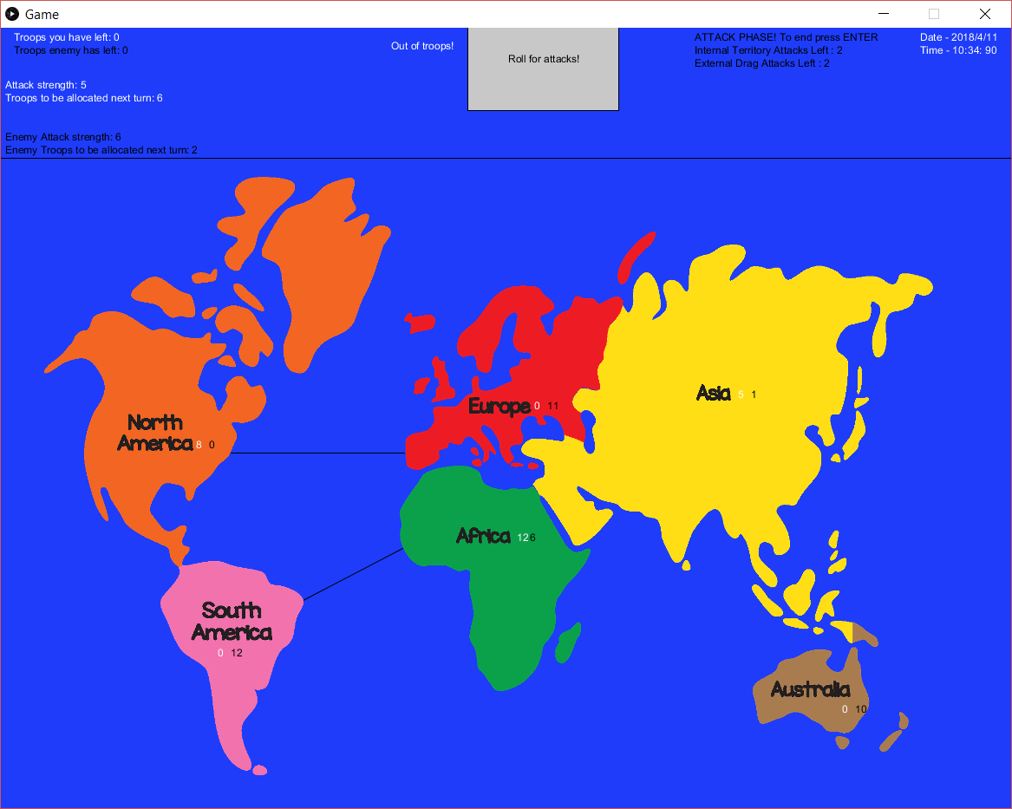 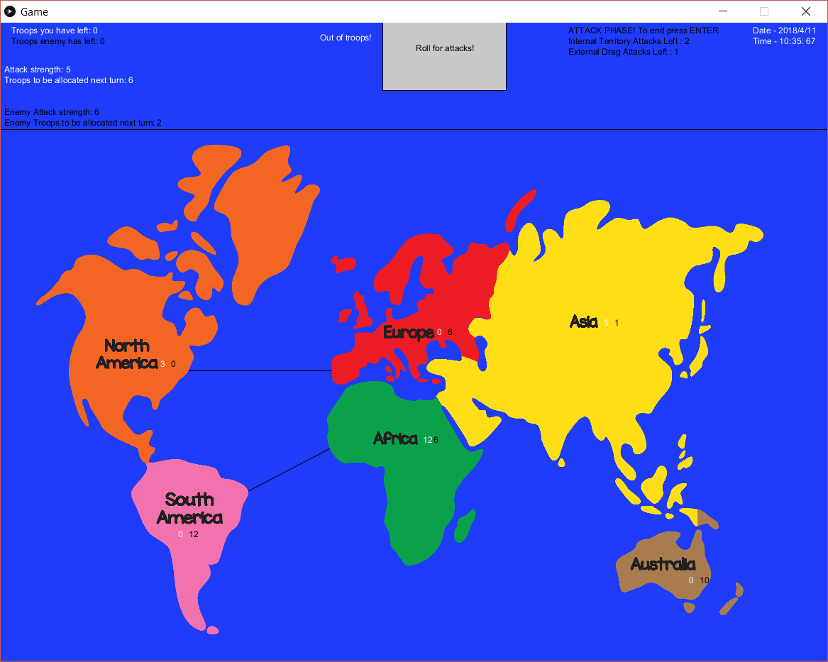

If you drag onto a territory that you own, you will transfer the amount of troops equal to your rolled attack strength to the new territory. A way of moving your armies around the map. 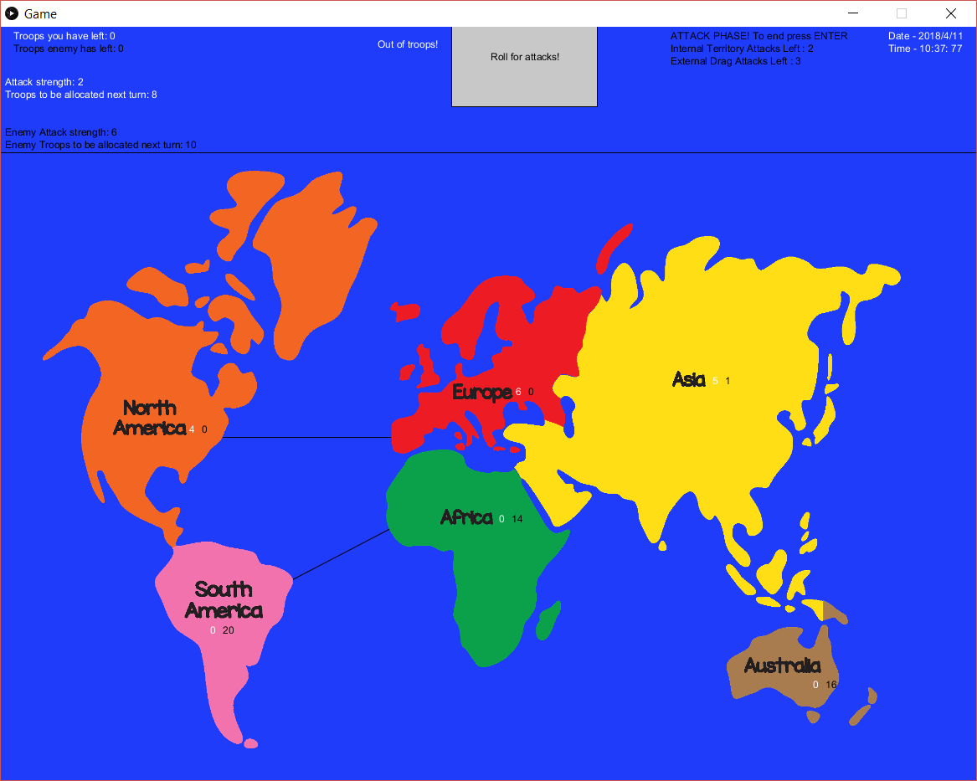

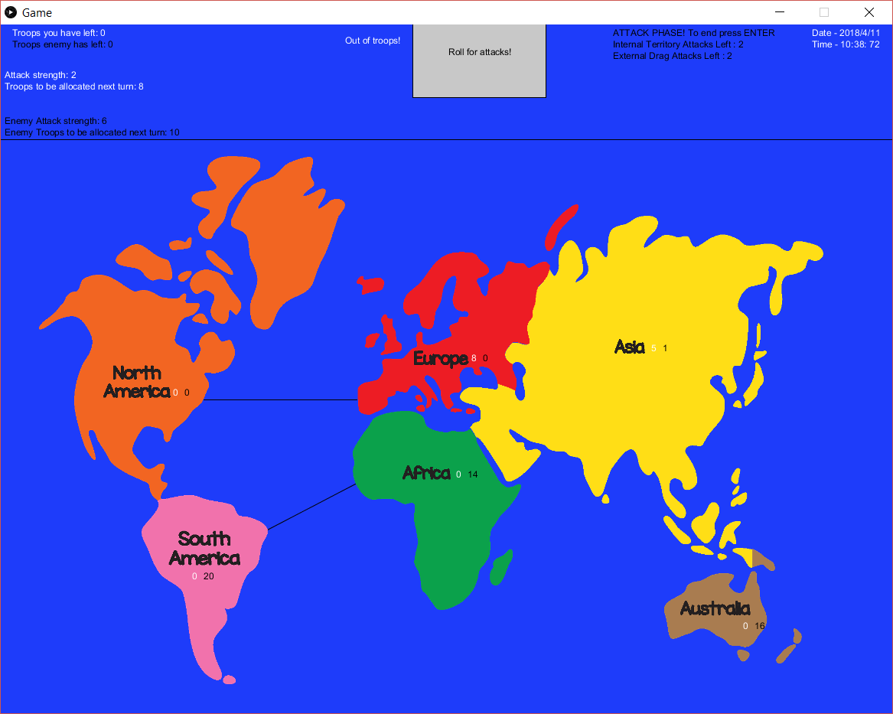

Be careful when doing this as it may leave you vulnerable!

## Winning/Losing

1. Winning - Own all territories, have troops in all 6 territories while the enemy has none in any of them. Total Domination.
2. Losing - All territories are owned by enemy, you have no troops on the map.

* Round counter runs out. 30 turns have passed, time loss.

# The Enemy

The enemy will get the same amount of troops for initial allocation, and will be rolled random attacks/troop reserves for themselves. The enemy will also get the same territory bonuses you would, so don’t let them get a head start. The difference is there attacks will be more random making them harder to predict and will randomly reduce territories when you use external attacks; so use them wisely.